Name:_____________________ Date:__________
Introduction to Quadratic Graphs
Objectives:
- Use tables to identify the properties of quadratic graphs
- Identify the vertex and axis of symmetry
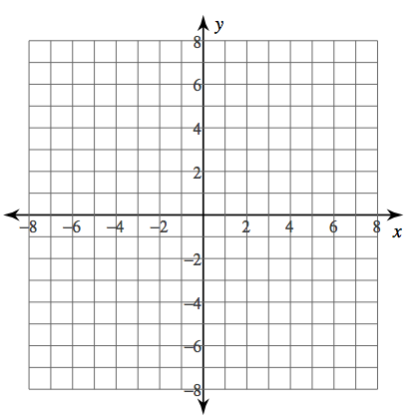
1) y = x² 2) y = 2x²
x | y
-2
-1
0
1
2
x | y
-2
-1
0
1
2

3) y = ½x²

x | y
-2
-1
0
1
2
4) Explain what happened from the parent graph (y = x² ) to the other two examples.

1) y = x² 2) y = x² + 3
x | y
-2
-1
0
1
2
x | y
-2
-1
0
1
2

3) y = x² – 3

x | y
-2
-1
0
1
2
4) Explain what happened from the parent graph (y = x² ) to the other two examples.

Quadratic Functions
Standard Form: y = ax² + bx +c
Examples:

The graph of a quadratic function is called a ______________________.
The parent function is _________________
The a-coefficient tells you if the graph opens ________________________.
The c-term tells you the __________________.
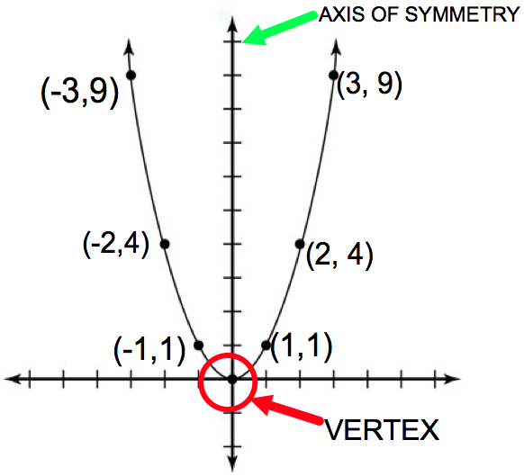
How to Find the Axis of Symmetry:

The axis of symmetry is ____________________
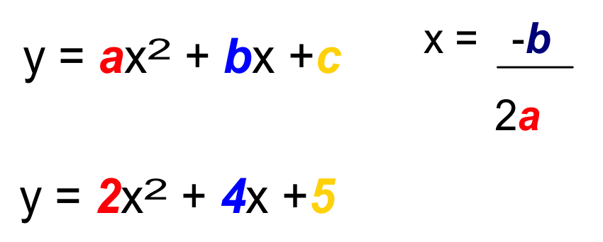
Ex. 1:

Ex. 2:
y = -3x² + 10x +9
Finding the Vertex:
Step 1: Find the Axis of Symmetry, this will give you the x-coordinate of the VERTEX

Step 2: substitute the x-coordinate from step 1 into the function, this will give you the y-coordinate

Step 3: Write the coordinate as an ordered pair.
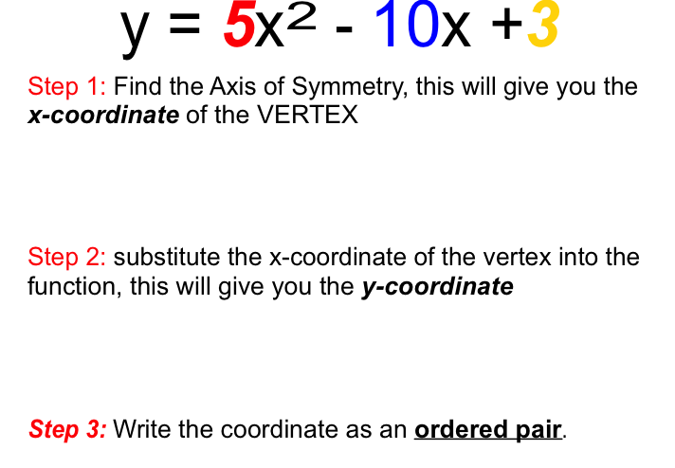
Ex. 1:

